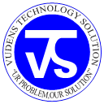

**VUDENS TECHNOLOGY SOLUTIONs**

***“…….Your Problem is our Solutions…….”***

**“Win the Power of IT Solution”**

**Juba, South Sudan.**

**Telephone No.: +211955270222/ +211926207085/ +211955085555**

**E-Mail : vudenstechnology@gmail.com**

***We Offer Services like: Computer Repair & Maintenance, Installation of Software, Printing of Banners, Stickers, Plastic IDs, Letterhead/Headed Paper, Certificates, T-Shirts, Wedding cards, Success Card, Business Cards, Invitation Cards etc.***

**COMPANY PROFILE**

**VUDENS TECHNOLOGY SOLUTION**

***EXECUTIVE DIRECTOR***

***CHIRI DENIS STEPHEN NIXON***

**Our Vision**

VUDENS TECHNOLOGY SOLUTION offers quality services in business environment with projects in variety of industries. We strongly believe in respecting the interests of our employees by creating a work environment that enable them to achieve career goals and satisfying clients work with their dedicated experience. We Respect our clients by providing the best professional consultants for the total satisfaction.

**Our Mission**

**“To Meet Each Client’s Business Vision”**

To provide and facilitate the delivery of quality, sustainable, customer oriented services efficiently and effectively.  
To consistently create value for our stakeholders, by providing solutions which enable our customers to achieve excellence and sustainable competitive edge with emerging technologies in IT fields.

**Our Core Values**  
**Innovation**  
Flexibility is the key to our offerings, and intrinsic to this flexibility, is the spirit of **Innovation** that we bring to our products and services - from the very stage of design to implementation and customer support.  
**Insight**  
At Vudens Technology Solution, we have always provided ourselves on the vision, skills, expertise and professionalism of our team. Our team members make use of their keen **Insight** to foresee industry trends and meet demanding customer needs. And the working of their collective minds in a highly supportive environment ensures that our products and services retain a competitive edge at all times.  
**Integrity**

At Vudens Technology Solution, we look at the Core Value of **Integrity** as the very soul of our company. This is reflected in our finances, the trusted relationship that we share with our customers and business partners, and the faith reposed in us by our stakeholders.

**Our Quality Policy**  
Vudens Technology Solution strives to provide service to its customers with emphasis on continuous improvement, pro-active approach, courtesy, timely response, and accuracy, with a goal of achieving total customer satisfaction.  
The Company is National & Internationally Delivery Model provides for the best resources to be drawn from its vast talent pool across the East Africa to offer optimal solutions. The Company integrates its products and services to create customized solutions to allow you to undertake technology-based Business transformation that allows reorganization in line with today's Dynamic Digital Business environment.

Vudens Technology Solution believes in assisting our clients with a full spectrum of Computer services. We do everything possible to make sure that we build quality systems to your Business & run at their best.

**Our Objectives for which a Company is established are:-**

Carry out Consultancy on Information Technology, Enterprise Network office automation and servicing/ supply of equipment & consumables therefore Provide Data and Records Management Consultancy services; Provide IT security (antivirus, firewalls, and training customer’s protection & IT user skills).

Conduct Research in Co-Temporally issues affecting the society and come up with IT solutions to help them mitigate their problems.

* Provide online hotel booking and tours and travel services, fleet management IT consultancy.
* Provide engraving services of corporate and domestic equipment’s.

**Vudens Technology Solution Provides A Complete List Of Services For Business As Follows:**



* Web designing & information systems



* Computer upgrades, maintenance & repairs

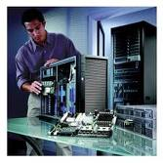

* Network certification, Servers configurations & maintenance



* Backup & recovery & Software installation

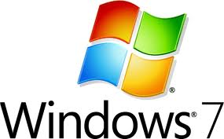

* Computer Virus protection, service, Scanning & Spyware removal

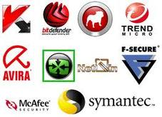

**IT skill training, Consultancy & research**

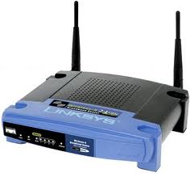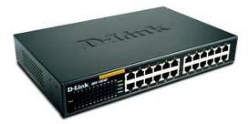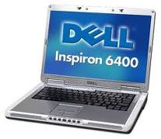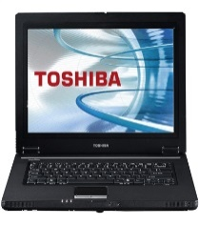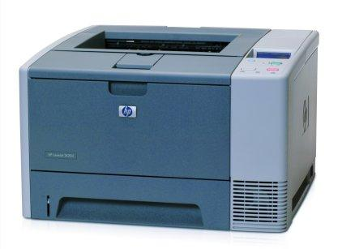

**We also offer services like;**

* Computer training in various courses such as Computer Application, Graphic Design, Computerize Accounting, Computerize Secretariat.
* General printing of items like;
* Plastic ID
* Banners
* Stickers
* T-shirts
* Letter head/ Headed paper
* Certificates
* Wedding cards
* Success cards
* Invitation cards
* Business cards
* Flyers
* Brochures
* Stamps
* Receipt/Vouchers books all size
* Success cards
* Caps
* Door labels
* Cups etc.

The strength of Vudens Technology Solution is to provide excellent Project Management and After Sales Support service. We undertake projects on a turnkey basis for the entire Business To maintain this service level, we have built our business around sophisticated quality management concepts, incorporating rigorous processes and robust project management controls that ultimately help secure the timely delivery of projects and highest quality results, within time and budget constraints.

**Experience**  
we specialize in networking, Computer Maintenance & Repair, web site development and information systems, web hosting, and office automation. Our staff offers quality and reliable services you can count on, our friendly & professional staffs are here to answer any questions you may have about our Company or our services, at **Vudens Technology Solution,** the customer always comes first. Our Business can make your Business look good and prospering.

Vudens Technology Solution deploys its five senses and more to deliver success beyond the ordinary, to its clients across East Africa and Africa.

At **Vudens Technology Solution** we believe in doing better than our best to help your Company leap across various challenging frontiers.

|  |  |  |
| --- | --- | --- |
| |  |  | | --- | --- | | |  | | --- | |  | | |



Vudens Technology Solution brings together a team of technology and business visionaries who steer the organization towards its ultimate goal to provide solutions to customers to enable them achieve excellence and sustainable competitive edge.

As technologies continually re-invent the ways business gets done, information itself is often an organization’s most valuable weapon. Keeping this in view, Vudens Technology Solution help the tech-savvy organizations to fulfill their **Business Vision** by offering **time-bound, high-quality, cost-effective** solutions that optimize their operations and move ahead of the competition.

Vudens Technology Solution is an Image / Voice / Data / IT consulting Company based in South Sudan, with dedicated expertise facilities in south Sudan.

The Company can anticipate its customers' needs, from corporate, small medium enterprises to large Enterprise Businesses

**Document Management Solutions:**

|  |  |
| --- | --- |
| A complete Document Management solution on Copy, Print, and Scan can be essential to your success in the new economy policies. Helping you to reduce time, overheads on consumables and proper accounting.  Vudens Technology Solution provides Document Management solutions that deliver exceptional value across your organization - meeting your business requirements, managing costs, reducing risk, and fulfilling your scheduling parameters. | laserjetparts  KM-5035 the multifunctional expert in document management |

**Software Development & Services:-**

We are advanced software powerhouse providing software development services for statement printing. Our solutions & services allow company to focus on their core businesses and yet be able to enlarge and augment their technical abilities.

**SOFTWARE LIFE CYCLE AT VUDENS TECHNOLOGY SOLUTION**

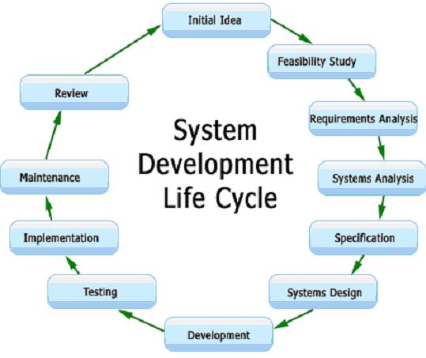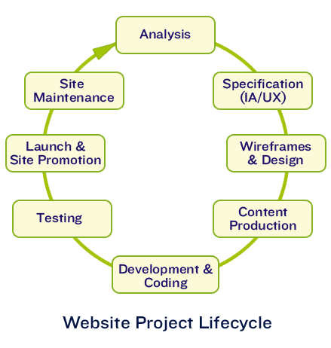

**Customer Relationship Management:**

|  |
| --- |
| A Customer Relationship Management solution can be essential to your success in the new economy. Helping you to develop multiple points of contact with customers, it enables you to consistently provide excellent customer service - on the telephone, over the Internet, by mail calling us on Skype.  Vudens Technology Solution provides Customer Relationship Management solutions that deliver exceptional value across your organization - meeting your business requirements, managing costs, reducing risk, and fulfilling your scheduling parameters. |

Our Customer Relationship Management consultants have extensive experience in designing, developing and deploying fully integrated call-center systems, sales-force automation, computer-telephony technologies, automated processes, and business applications.

**Products Range:-**

The enterprises of present day have a range of business needs and technology necessities.

Vudens Technology Solution delivers unmatched professional expertise to service the entire range of requirements. Vudens Technology Solution Consultants and professionals work along with the client’s staff during the entire project life cycle to assess, plan, develop and deploy products, services and workflow processes.

At Vudens Technology Solution, we pride ourselves on anticipating our customer’s needs and delivering the right products and services to meet those needs.

From enterprise integration to web enabled business solutions, our products ensure you get the right solution at the right time.

Vudens Technology Solution develops both packaged and customized products. Our focus is on developing robust, scalable, and secure web enabled enterprise products that can be deployed over the Internet.

**Partial product portfolio at Vudens Technology Solution**

**CANON Range of Products:**

* Plain Paper Copiers (Digital)
* Facsimile Equipment
* Printers (Standalone & Network)
* Scanners
* Document & Image Management Systems
* Photo _Video Digital Cameras
* Calculators

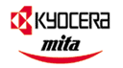 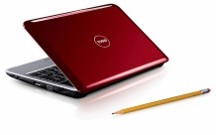

**Range of products**

* Low Printing cost Laser Printers.
* AO Plain paper copiers.
* Business Communication Products for SMEs
* Digital Voice Communication Servers for Large Entreprises
* Interactive Voice Communication Servers
* Call Center Applications
* Hotel Applications
* Voice and Data Networks

**SOFTWARE Packages:-**

* Microsoft Office Applications
* Windows Operating System



* Red Hat Linux
* Norton Anti-Virus
* E-scan Antivirus
* MacAfeeAntivirus

**DELL Range of Products:-**

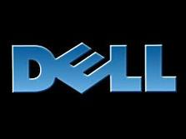

Desktops and MFP’s, Laser Printers, Laptops, Servers, Storage Systems, Tape Drives, Switches, Projectors, PDA.

**Milestones Achieved:-**

Vudens Technology Solution has executed a number of projects successfully at a small scale and is increasingly expanding a great clientele. The success of Vudens Technology Solution lies not only in successfully completing the projects in time, but in understanding the client’s requirements effectively and executing them.

**Some of the coveted clients of Vudens Technology Solution are:**

* SNV- Netherlands Organization
* Yama Alex Company Ltd
* MarkErick & desire Associates
* Tumu Consultant Engineering Company
* Gospel of God Church International
* Rural Children Development Organization
* China Oversees Engineering Company
* ABMC
* Nehemiah Trumpet Call FM
* APEBA
* Bright Business Enterprises Ltd
* Juba City Council. Chamber of Commerce, Industry & Agriculture